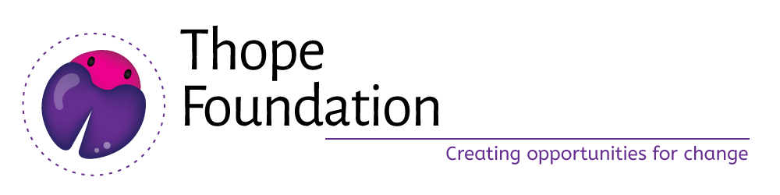

Proposal submitted to:

August 2017

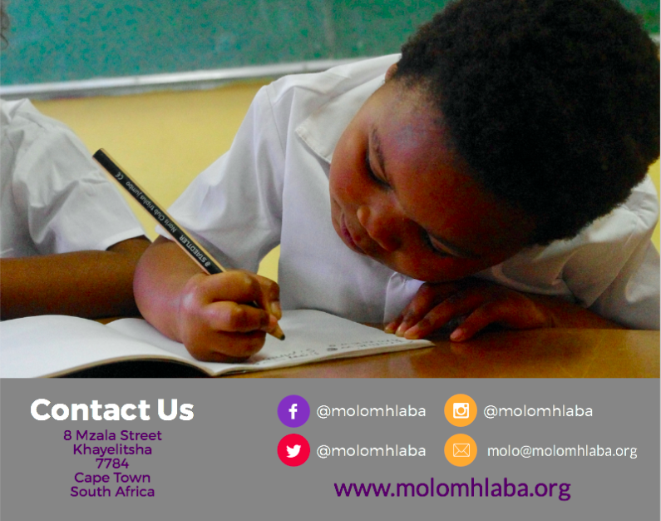
Submitted by Rethabile Sonibare, rethabile@thopefoundation.org , 021 361 0077

Background to Thope Foundation
Since it was established in 2013 Thope Foundation has supported Grade 5, 6, 7 and 8 girls with Maths, Science and English tutoring on a weekly basis. We currently have sixteen young women, mostly university students, who volunteer every Saturday morning to tutor Maths, Science, English and Lifeskills while our Robotics and Computer Programming takes place over school holidays. In 2015, Grade R-4 learners were introduced to the organisation as part of numeracy and literacy remedial support in the early years. Our programs run Monday to Saturday during school term.

In line with providing holistic development programs for young girls, Thope Foundation offers the following integrated weekly programs:

- Education Support Program: weekly Maths and English tutoring which reaches over 100 girls a year,
- Life skills: Weekly sexual reproductive health education, leadership, mentoring, life skills and youth campaigns for special events for over 400 girls a year,
- Holiday programs: Annual events hosted during school holidays with a focus on engineering (robotics), computer science (coding & programming) and cultural activities,
- Mama-mentors: Is a series of intergenerational dialogues between Thope girls and their female caregivers in an attempt to strengthen supportive networks for girls transitioning to high school.
- Early Learning Program: Thope runs remedial support sessions in numeracy and literacy for learners in Grade R to Grade 4 as well as popularizing reading in mother-tongue (Xhosa) for learners in underserved communities.
- Thope Foundation Club House: Is a literacy centre and library providing educational materials and books to improve literacy and encourage reading for enjoyment and thereby improve the language and general knowledge skills of the girls and Foundation Phase children at the school. Annually we reach over 700 unique learners who loan over 20 books each.
- Molo Mhlaba Schools: Is a new venture, established in 2016, that will support a network of high impact Pan-African schools across South Africa.

Governance
As a registered non-profit organisation, we are governed by board of directors who guide the strategy, decision-making and fiduciary oversight of our organisation. The board is made up of the following individuals who provide the organisation with skills, time and networks on a voluntary basis:

Xolisa Guzula, Chairperson
Xolisa Guzula is a biliteracy teacher and community trainer, researcher, storyteller, author and translator of children's literature. She is one of the founders of the network of community literacy reading clubs emerging across South Africa. She has worked as a biliteracy specialist at the Project for the Study of Alternative Education in South Africa (PRAESA) and as a Senior language and Literacy Specialist at the Nelson Mandela Institute for Education and Rural Development. She is currently doing full time doctoral studies at the University of Cape Town. Her research focuses on children's translanguaging and multiliteracy practices.

Sibongile Khumalo,
For 9 years, Sibongile worked with a high school scholarship programme where she focused her time on providing support to underprivileged children who were awarded scholarships to attend affluent schools. Sibongile believes that all young people can have access to quality education if local community members organize themselves and build partnerships to supplement what is offered at the majority ill-resourced public schools in the country. She holds a Master of Science degree and currently heads operations at BRIDGE, an education systems change organisation. As part of her community work, she has started libraries, tutored primary school children, and now voluntarily manages a Saturday school programme. Sibongile has recently also started an Afternoon Academy that uses the creative arts to help kids fulfil their own unique potential.

Fiona Burtt,
Is an Early Childhood Development (ECD) and education specialist who has worked in social justice, primarily in South Africa and across the Southern Africa region, as well as overseas. She is originally from the UK, but has lived in Cape Town since 2006. In 2010, she moved into philanthropy, managing the ECD and education programme for an international funder based in South Africa, leaving in 2013 to leap into consultancy. Fiona has a Masters in Archaeology & Anthropology and, more recently, studied for an International Diploma in Montessori Pedagogy. She has worked as an archaeologist in the UK, Italy and Syria, before being led by a love of literature into the book publishing industry and then journalism.

Portia Lujabe,
Portia is a long serving volunteer of the Thope Foundation. She is currently in her third year of study reading towards a Psychology degree at Stellenbosch University. She is a social activist and advocate for girls’ education.

Mica Townsend, Treasurer
Originally from London in the UK, Mica Townsend has been living in Cape Town for the past 2.5 years. She graduated with a first-class honours degree in Economics and Management from Royal Holloway, University of London and has been working in the finance industry since 2010. Her first experience of South Africa was in 2012 through a 6-month secondment with Barclays Wealth. As part of their 3-year Private Banking Graduate Programme she had the opportunity to work at Absa Wealth in Sandton. Having loved every minute of her South African experience, Mica decided to make a permanent move back to the country. Since moving to Cape Town in late 2013 Mica has been working for deVere Acuma, (part of the deVere Group – the world’s largest independent financial consultancy) as a Wealth Consultant; advising expats and High Net Worth individuals on how to access the offshore investment markets and helping them to achieve their long term financial goals. Mica is registered with the Financial Services Board and as a CFA Charterholder is part of the prestigious CFA Institute. She would like to use her skillset and time to benefit the wider society and looks forward to working with the Thope Foundation as part of the Board.

Athambile Masola,
Athambile is a former English teacher at Claremont High School and currently works at a private school teaching English in senior phase (Grade 8-12). She completed a Masters in Education as a Mandela-Rhodes Scholar at Rhodes University. Her thesis focussed on teaching literacy in Foundation Phase classrooms where isiXhosa is the LOLT in impoverished Grahamstown schools. She is a PhD candidate at Rhodes University and works at the University of Pretoria as a lecturer in Education. As a teacher, she has a keen interest in literacy development across all levels of education. She is also a writer and her work has been featured in the *Mail and Guardian*, *Daily Dispatch*, *Sowetan* and various online blogs (Mail and Guardian Thought Leader and Bokamoso).

Thabisile Cylvia Smit
Thabisile holds a BA and LLB degree from the University of Cape Town. She has been in the legal practice for the past 13 years and is currently a Director at Smith Tabata Buchanan Boyes (STBB) Attorneys, a position she has held for 4 years. She is an Admitted Attorney of the High Court, Conveyancer, Notary Public, Liquidator and an Adjudicator for the Community Scheme Ombud Service. Thabisile is actively involved and sits on the board of a registered non-profit organisation called, UPHAWU Community Development. UPHAWU is mainly funded by STBB and their clients. This organisation runs several projects in Samora Township such as the literacy program and a shoe donation campaign, ‘No More Bare Feet’, where school shoes are donated to underprivileged children across the Eastern Cape.

Our staff:

Rethabile Mashale, Board Secretary and Program Director,
Rethabile is a registered Social Worker and PhD student at Stellenbosch university. She previously worked as Programme Officer for The Learning Trust-a conduit funder supporting grassroots education initiatives. She holds an MSocSc in Social Policy and Management degree from the University of Cape Town. Her thesis focussed on monitoring and evaluation within the non-profit sector. She has several years’ experience working for non-profit organisations and has focused on emerging community initiatives in the education and youth development sector. Prior to The Learning Trust, she worked as a junior researcher at CADRE (Center of AIDS Development, Research & Evaluation) working in HIV research and evaluation across Southern Africa.

Mahaneng Phali, Program Coordinator (ESP),
Mahaneng Phali is a Program Coordinator at Thope Foundation, she has a Diploma in Management Studies and is a North-West native. She lives in her adopted home of Cape Town and has a long-standing history of education activism starting in high school, then through higher education youth structures and now in civil society. Prior to joining Thope Foundation, she worked for BoxGirls an international violence prevention through education program for primary school girls. She joined Thope in 2016 as a Program Coordinator supporting the STEAM (science, technology, engineering, arts and design and maths) program for primary school girls, thereby, continuing her passion for girls and education.

Nolwandle Timla, Program Coordinator (ELP),
Nolwandle is studying towards a Level 4 Early Childhood Development qualification and has coordinated Thope’s ELP programs since 2015. She started as the Thope Club House librarian and has grown into the senior leadership role of coordinator. Nolwandle dreams of being an educational psychologist for Molo Mhlaba learners.

Nasiwe Timla, ELP assistant and librarian,
Nasiwe joined out team as a volunteer and we have invested in her education to study towards a Level 4 Early Childhood Development and trained her to manage our library.

Sizeka Nkohla, intern
Sizeka joined Thope Foundation as an Intern, in a 1 year (April 2017- April 2018) contract. She has a Diploma in Management (2013-2015) and Bachelor of Technology in Human Resource Development (2016) and is an Eastern Cape native. She lives in Cape Town. During her studies, she completed an experiential training 3-month placement at Lewis Stores.

Background to Molo Mhlaba (Hello World) Schools

South Africa ranks the worst in educational outcomes on all major international studies for middle income countries that participate in cross-national assessments of educational achievement, particularly in mathematics. These poor results are despite the 17.5 % of national GDP being invested in education. South Africa even performs worse than low income countries in Africa. South Africa’s large financial investment does not translate into improved educational outcomes. The Trends in International Mathematics and Science Study (TIMSS) is an international standardised test for mathematics and science indicates that the average mathematics competencies at Grade 9 in South Africa on the standardised test were closest to last in 2011 (apart from Honduras and Morocco).

The 2011 TIMSS data shows that the teaching of mathematics in South African schools is amongst the worst in the world and therefore South African learners have the lowest performance among all 21 middle-income countries who participate in the study. Dr Nick Taylor, in his most recent report as Head of the Department of Basic Education’s National Education Evaluation and Development Unit (NEEDU), argues that poor learner performance in most schools is largely due to the poor subject knowledge of teachers, especially in mathematics. Furthermore, the NEEDU report points to the rampant patronage and ‘jobs for cash’ plaguing the Department which can be linked to teacher complacency, skills and experience and lack of subject knowledge. There are myriad other issues that contribute to the failing of learners particularly in Grade 3,6 and 9 maths, science and English which are closely related to teacher competence, retention, professional development and school management.

There is mounting evidence that school performance and poor teaching are largely unacknowledged as significant contributors to the failure of the standard of public education in South Africa. Improving teacher competencies and school leadership, can vastly improve the educational attainment of learners in South African public schools, however, there is increased polarization of schooling spurred by the growing private school chains and declining quality in public schools.

We believe that systemic exclusion of poor children, an economically polarized education (public vs private education) has led and continues to contribute to the class and educational inequality that persists in South Africa. The Molo Mhlaba model offers a variety of solutions, primarily schooling for our country’s poorest and most vulnerable citizens, its children. We believe that children from under resourced homes, particularly African communities, are resilient, resourced in human capital and have the potential to flourish under the right conditions. Therefore, we believe that African children have the potential to be anything they want to be and have equal potential to their middle-class counter parts. Evidence derived from our community survey indicates that:
- 100% of adults in underserved communities, particularly Khayelitsha, want single sex schools as they believe it will lead to safer learning and teaching environment for girls,
- 47% want a better education for their girls,
- 26% want improved child safety in school,
- 17% want a girl child oriented teaching and learning environment,
- 9% want decreased teenage pregnancy

In Cape Town, Molo Mhlaba Khayelitsha would be the first single sex school of its kind to offer STEAM (science, technology, engineering, art and design and maths) as part of a network that will have 10 schools in 5 provinces in the next 12 years.

The Molo Mhlaba Model

Our vision is to awaken and foster possibility in African children so they can imagine, access and create the world they live in.

Our mission is to bring the world of possibility closer to African children through exploration, imagination and learning, so they can be responsible, productive, hopeful and equipped citizens. We do this through quality education provision, community engagement and partnerships that contribute to widening opportunities for children.

Our values are:
- Punctuality,
- Creativity
- Hopefulness,
- Opportunity driven,
- Entrepreneurial in action and behaviour,
- Resilience
The Molo Mhlaba Schools are a network of nonprofit low fee Pan-African independent schools providing quality STEAM education through innovative teaching and learning strategies for learners and by teachers from underserved communities. The Molo Mhlaba Schools will host single sex and coeducation schools depending on locality. Molo learners will foster creativity, collaboration, critical thinking and citizenship through an inclusive and responsive education model for learning and teaching. Our learners, regardless of background, class or religious associations have equal opportunities to be productive citizens of the 21st century.

The Molo Mhlaba Schools will offer underserved children quality education that centres African history, cultures, knowledge, stories, traditions, languages and equips learners with the skills and fortitude to be leaders who develop solutions to African problems. MM Schools does this through high impact quality teaching, coaching and mentoring of learners and educators in fields of STEAM using technology and teaching strategies personalised to individual learners.

Our goals are:
- To provide high quality education for learners coming from disadvantaged backgrounds,
- To recruit, support and retain high quality African teachers from the communities where the schools are located and where the learners emanate,
- To provide conditions and pedagogy that best support quality learning of maths, science, lifeskills and language,
- To build strong primary school foundations for future learning,

At Molo Mhlaba, we believe that the skills children need to be impactful leaders of tomorrow are made up many things but our most important are the 5 ingredients for our schools. Our school will be run as follows:

- Extended school day: The school day will be from 7:30am to 4pm so that working parents can drop of children and collect them, children are kept safe and engaged through experiential afterschool care programs run by the school and therefore creating additional employment opportunities for women in the community.

- Nutritious meals: Learners will be served two hot meals (breakfast and lunch) and two snacks to ensure healthy minds and bodies. This will be done through existing partners like the Lunchbox Fund/WC School Nutrition Program as well as a fully functional catering kitchen onsite.

- Highly qualified teachers: with a teacher to learner ratio of 1:25: Smaller classrooms make for better learning environments and a manageable workload for teachers and their assistants. Teachers will be highly qualified mentors enrolled in Continued Development Programs and recruited from the same community as the school (Khayelitsha).

- Located in the same communities as the children: By housing schools in the same communities as the children, we reduce the travel time required between getting to and from schools, save parents money on additional transport costs and positively impact the mental health and identity of learners by showcasing what is POSSIBLE in their communities. We will model both teacher excellence and what a high impact STEAM school for children looks like in underserved communities.

- Leadership training for children and teachers: We will invest in active leadership training programs for both faculty and learners at the Molo Mhlaba Schools. By growing a cohort of inspired teachers and learners, we are contributing to active citizenry from an early age so that children grow to be strong, confident and resilient women ready to take on the challenges of Africa.

Curriculum inspiration:
In addition to developing elements of our own curriculum, we will adapt the following learner centred curriculums and approaches:
- Waldorf Education for learning through play and teacher development,
- Montessori for graded learning and appropriate life-lesson development, and
- In the Senior Phase, we will introduce CAPS aligned e-learning to prepare learners for entry into high impact high schools.

The subject offering for the Molo Mhlaba Schools will be as follows:

- Literacy and numeracy (Maths)
- Leadership and lifeskills,
- Mindfulness and yoga
- Languages (English, Xhosa, Swahili, Arabic, French, Sotho)
- Social sciences (History, life sciences and geography)
- Economic Management Systems (EMS)
- Entrepreneurship
- Engineering
- Computer Science
- Arts, music and drama
- Career guidance
- Debate and public speaking
- Physical education (soccer, rugby, yoga, martial arts/self-defense, indigenous games, swimming)

For our first school in Khayelitsha, we have the following distinguishing factors:

- Our learners have the same teacher/class champion for each entire phase (except ECD), with addition of specialist subject champion for specific needs.
- We are a school for girls in Khayelitsha. There currently is no single sex school for girls and therefore we are pioneering this model by bringing our value offering to underserved communities like Khayelitsha.
- High quality low fee private school located in under resourced communities reduces the transport costs for parents and changes the daily migration patterns currently experienced when parents send their kids out of townships to ‘better’ schools.
- Highly qualified subject champions as lead coaches/teachers for subject implementation.
- Continued professional development and mentoring of new teachers ensures that our teachers possess the highest quality skillset.
- By growing “own wood” in training subject champions and assistants, we directly influence the curriculum delivery and maintenance of high quality standards.
- Create over 50 employment positions for women and additional employment opportunities for women to participate in the formal economy.
- We can directly grow the budding township economy for education social entrepreneurs and therefore start to contribute to the developmental objectives of government’s National Development Plan for socio-economic development.
- Lastly, we will be the ONLY STEAM primary school for girls in Khayelitsha, this allows us the opportunity to lead in this area.

In 2018, we will:
- Recruit 60 learners in Grade 0 (3-5 year olds). Never in the other grades.
- Employ two Level 5 trained teachers and two assistants,
- Run a 6-day school (Monday to Saturday) for children,
- Operating hours are 7:30am to 4pm each day with formal tuition ending at 12:30pm and afterschool starting thereafter.
- In-crowd NGO partners, professionals to run our ‘Master Classes’ and offer enriching afterschool programs.
- Offer Master Classes: are 3-day career and experiential learning activities offered by volunteers from around the world in their areas of interest/career for learners, parents and community youth.

Ways to get involved
In addition to assisting us with fundraising for our proposed operational budget for the Khayelitsha Campus and forming an implementation partner, we envisage partnership in the following ways:
- Molo Mhlaba can host short and long-term volunteers for select areas for the Master Classes which can be tailored to fit volunteer profiles based on school curriculum,
- Volunteers can mentor our senior team on launching and managing social enterprise ventures,
- Volunteers can mentor our girls online (in line with our child protection policy)
- Molo campus can offer event space for Women In STEM networks,
- Thope Foundation and Molo Mhlaba Schools can leverage the international reach and networks that of volunteers as we expand,
- Thope can learn from the global networks that THAF has developed,
- We are also open to suggestions about opportunities and ways to partner.

Please see the attached Khayelitsha Campus budget for 2017 to 2022 where we are asking for help to raise some of the costs associated with establishing our first campus and building capacity in our central office which will support Molo’s expansion to 10 schools in the 5 provinces over a 12 year period.

